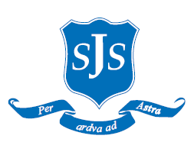
Dear Parents/Carers,

EYFS Relationship and Health Education (RHE)

RHE teaching will take place throughout the academic year as part of our whole school PSHE curriculum. Our RHE curriculum is delivered through the Life to the Full programme by Ten:Ten and supports pupils in developing healthy relationships, emotional wellbeing and an understanding of their place in the wider community.

The EYFS programme will include the following lessons:

Term 2
- Story Session: Handmade with Love
Term 3
- I Am Me
- Heads, Shoulders, Knees and Toes
- Ready Teddy?
Term 4
- I Like, You Like, We All Like!
- All the Feelings
- Let's Get Real
Term 5
- Growing Up
- God is Love
- Loving God, Loving Others
Term 6
- Me, You, Us

Our scheme of work provides progressive learning throughout the school, enabling children to develop an understanding of healthy and positive relationships, personal wellbeing and responsible citizenship.

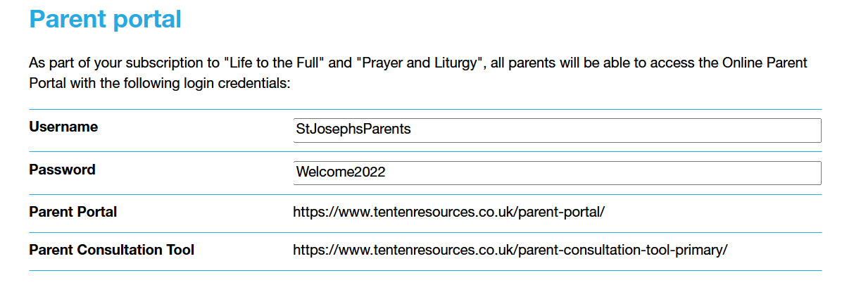

If you have any questions regarding the RHE curriculum, please contact the school office.

Yours sincerely,
Ms L Bourne
RHE Lead

