Dear Parents/Carers,

Year 1 Relationship and Health Education (RHE)

RHE teaching will take place throughout the academic year as part of our whole school PSHE curriculum. Our RHE curriculum is delivered through the Life to the Full programme by Ten:Ten and supports pupils in developing healthy relationships, emotional wellbeing and an understanding of their place in the wider community.

The Year 1 programme will include the following lessons:

Term 2
- Let the Children Come
- God Loves You

Term 3
- Special People
- Treat Others Well
- ...and Say Sorry

Term 4
- Good and Bad Secrets
- Physical Contact
- Harmful Substances
- Can You Help Me? Part 1
- Can You Help Me? Part 2

Term 6
- Three in One
- Who Is My Neighbour?
- The Communities We Live In
- Who Will I Be?

Our scheme of work provides progressive learning throughout the school, enabling children to develop an understanding of healthy and positive relationships, personal wellbeing and responsible citizenship.

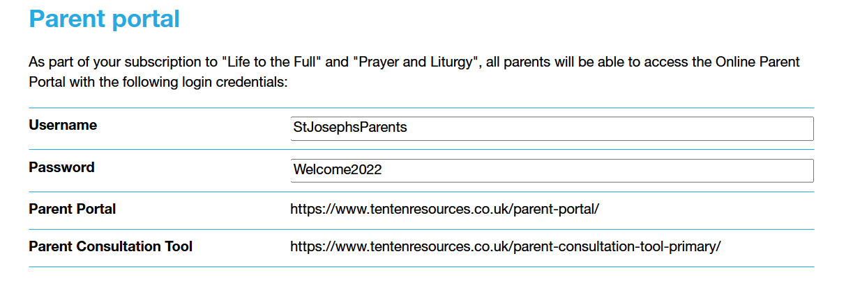

If you have any questions regarding the RHE curriculum, please contact the school office.

Yours sincerely,
Ms L Bourne
RHE Lead

