Dear Parents/Carers,

Year 3 Relationship and Health Education (RHE)

RHE teaching will take place throughout the academic year as part of our whole school PSHE curriculum. Our RHE curriculum is delivered through the Life to the Full programme by Ten:Ten and supports pupils in developing healthy relationships, emotional wellbeing and an understanding of their place in the wider community.

The Year 3 programme will include the following lessons:

Term 2
- Get Up!
- The Sacraments
- Jesus, My Friend

Term 3
- Family, Friends and Others
- When Things Feel Bad
- Sharing Online
- Chatting Online

Term 4
- Safe in My Body
- Drugs, Alcohol and Tobacco
- First Aid Heroes
- Rights and Responsibilities

Term 6
- A Community of Love
- What Is the Church?
- How Do I Love Others?
- Working Together

Our scheme of work provides progressive learning throughout the school, enabling children to develop an understanding of healthy and positive relationships, personal wellbeing and responsible citizenship.

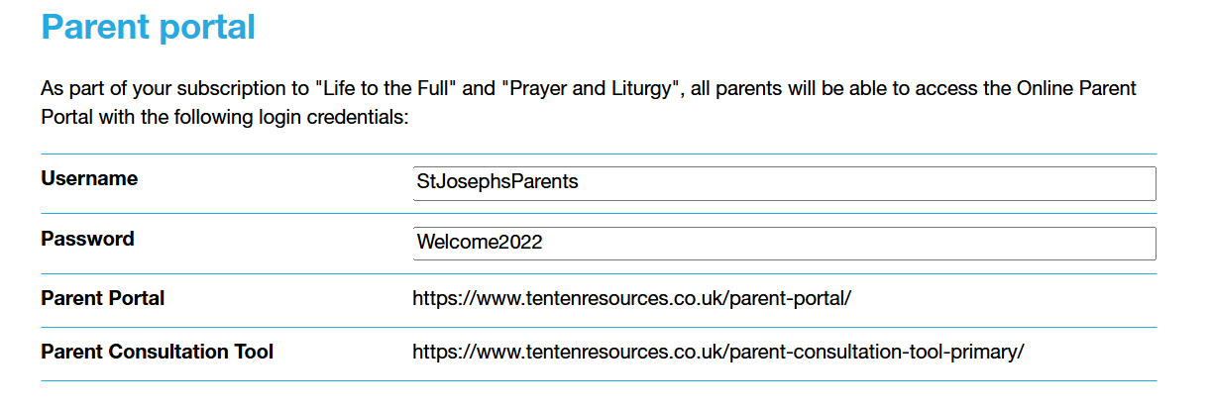

If you have any questions regarding the RHE curriculum, please contact the school office.

Yours sincerely,
Ms L Bourne
RHE Lead

