Dear Parents/Carers,

Year 4 Relationship and Health Education (RHE)

RHE teaching will take place throughout the academic year as part of our whole school PSHE curriculum. Our RHE curriculum is delivered through the Life to the Full programme by Ten:Ten and supports pupils in developing healthy relationships, emotional wellbeing and an understanding of their place in the wider community.

The Year 4 programme will include the following lessons:

Term 2
- Get Up!

Term 3
- We Don't Have to Be the Same
- Respecting Our Bodies
- What Is Puberty?
- Changing Bodies

Term 4
- What Am I Feeling?
- What Am I Looking At?
- I Am Thankful

Term 5
- Life Cycles
- A Time for Everything
- Big Changes, Little Changes
- A Community of Love
- What Is the Church?
- How Do I Love Others?
- Money Matters

Our scheme of work provides progressive learning throughout the school, enabling children to develop an understanding of healthy and positive relationships, personal wellbeing and responsible citizenship.

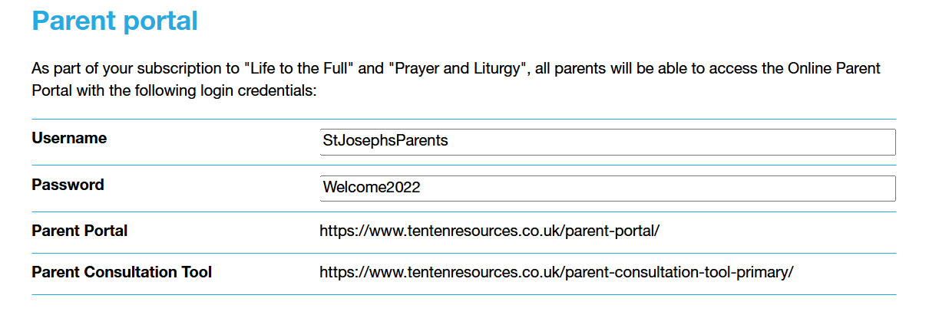

If you have any questions regarding the RHE curriculum, please contact the school office.

Yours sincerely,
Ms L Bourne
RHE Lead

