Dear Parents/Carers,

Year 6 Relationship And Health Education (RHE)

RHE teaching will take place throughout the academic year as part of our whole school PSHE curriculum. Our RHE curriculum is delivered through the Life to the Full programme by Ten:Ten and supports pupils in developing healthy relationships, emotional wellbeing and an understanding of their place in the wider community.

The Year 6 programme will include the following lessons:

Term 2
- Calming the Storm
- Gifts and Talents
- Girls' Bodies
- Boys' Bodies
- Spots and Sleep

Term 3
- Body Image
- Peculiar Feelings
- Emotional Changes
- Seeing Stuff Online
Term 4
- Making Babies (Part 1)
- Making Babies (Part 2)
- Menstruation
- Hope Beyond Death
- Coping with Change
Term 6
- Build Others Up
- The Holy Trinity
- Catholic Social Teaching
- Reaching Out
- Money and Me

Our scheme of work provides progressive learning throughout the school, enabling children to develop an understanding of healthy and positive relationships, personal wellbeing and responsible citizenship.

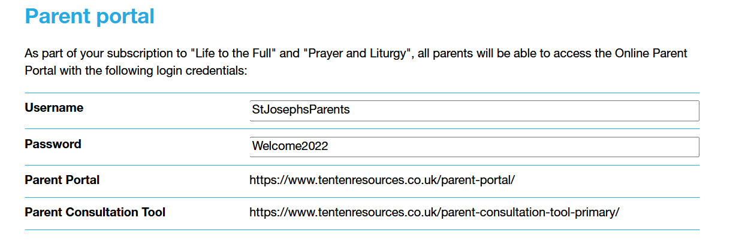

If you have any questions regarding the RHE curriculum, please contact the school office.

Yours sincerely,
Ms L Bourne
RHE Lead

